Sultan Qaboos University
College of Engineering
Department of Electrical & Computer Engineering

Course Title: DIGITAL LOGIC DESIGN
Course Code: ECCE 3206
Total Marks: 40
Instructors: Dr. Afaq Ahmed (10),Dr. Tariq Jamil (20),& Dr. Ayman Elnaggar (30&40)

Name:__________________________________  I.D.: ___________________________________  Section No.  OR Instructor’s Name: ___________________ | QI | / 5
 | QII | / 5
 | QIII | / 5
 | QIV | / 10
 | QV | / 15
 | TOTAL | /40

FINAL EXAMINATION – Spring 2009 – SAMPLE SOLUTION
18 May 2009 – Monday 11:30 AM – 1:30 PM - CMT C1/C2/C3/C5/C10/C14/C15

Instructions
- Answer all questions.
- Make sure your copy of the exam-paper consists of THIRTEEN pages (including this page).
- This examination carries 40% weight in the calculation of your overall grade in this course.
- The marks allocated to each question are as indicated in the exam-paper.
- This is a closed-book/closed-notes examination.
- Remember to put your name, I.D. number, Section number or Instructor’s name on the exam-paper.
- Answers must be written in blue or black ink (preferred) or pencil.
- Show all your work and state all assumptions. Partial credit cannot be given for work not shown.
- You are not allowed to share any of your writing/computing instruments, like pen, pencil, calculator, eraser, etc. with anyone in the exam room.
- Candidates are not allowed to enter after the first half hour (30 min) from the start of the examination.
- Candidates are not allowed to leave the examination room during the first half hour (30 minutes) from the start of the examination.
- A candidate arriving late, but within the first 30 minutes from the start of the examination has the same scheduled finish time as of the other candidates.
- Hand-in your exam-paper to the invigilator when you leave the exam room.
- Any academic misconduct (use of any dishonest or deceitful means to gain academic advantage or benefit) or misbehavior or disturbance of the exam room discipline and decorum will be strictly dealt with under the rules and regulations of the University.

J | K | Q(t+1)
0 | 0 | Q(t)
0 | 1 | 0
1 | 0 | 1
1 | 1 | $$\bar{Q}(t)$$
JK RS D T
S | R | Q(t+1)
0 | 0 | Q(t)
0 | 1 | 0
1 | 0 | 1
1 | 1 | Unknown
D | Q(t+1)
0 | 0
1 | 1
T | Q(t+1)
0 | Q(t)
1 | $$\bar{Q}(t)$$

Flip-Flop Characteristic Tables

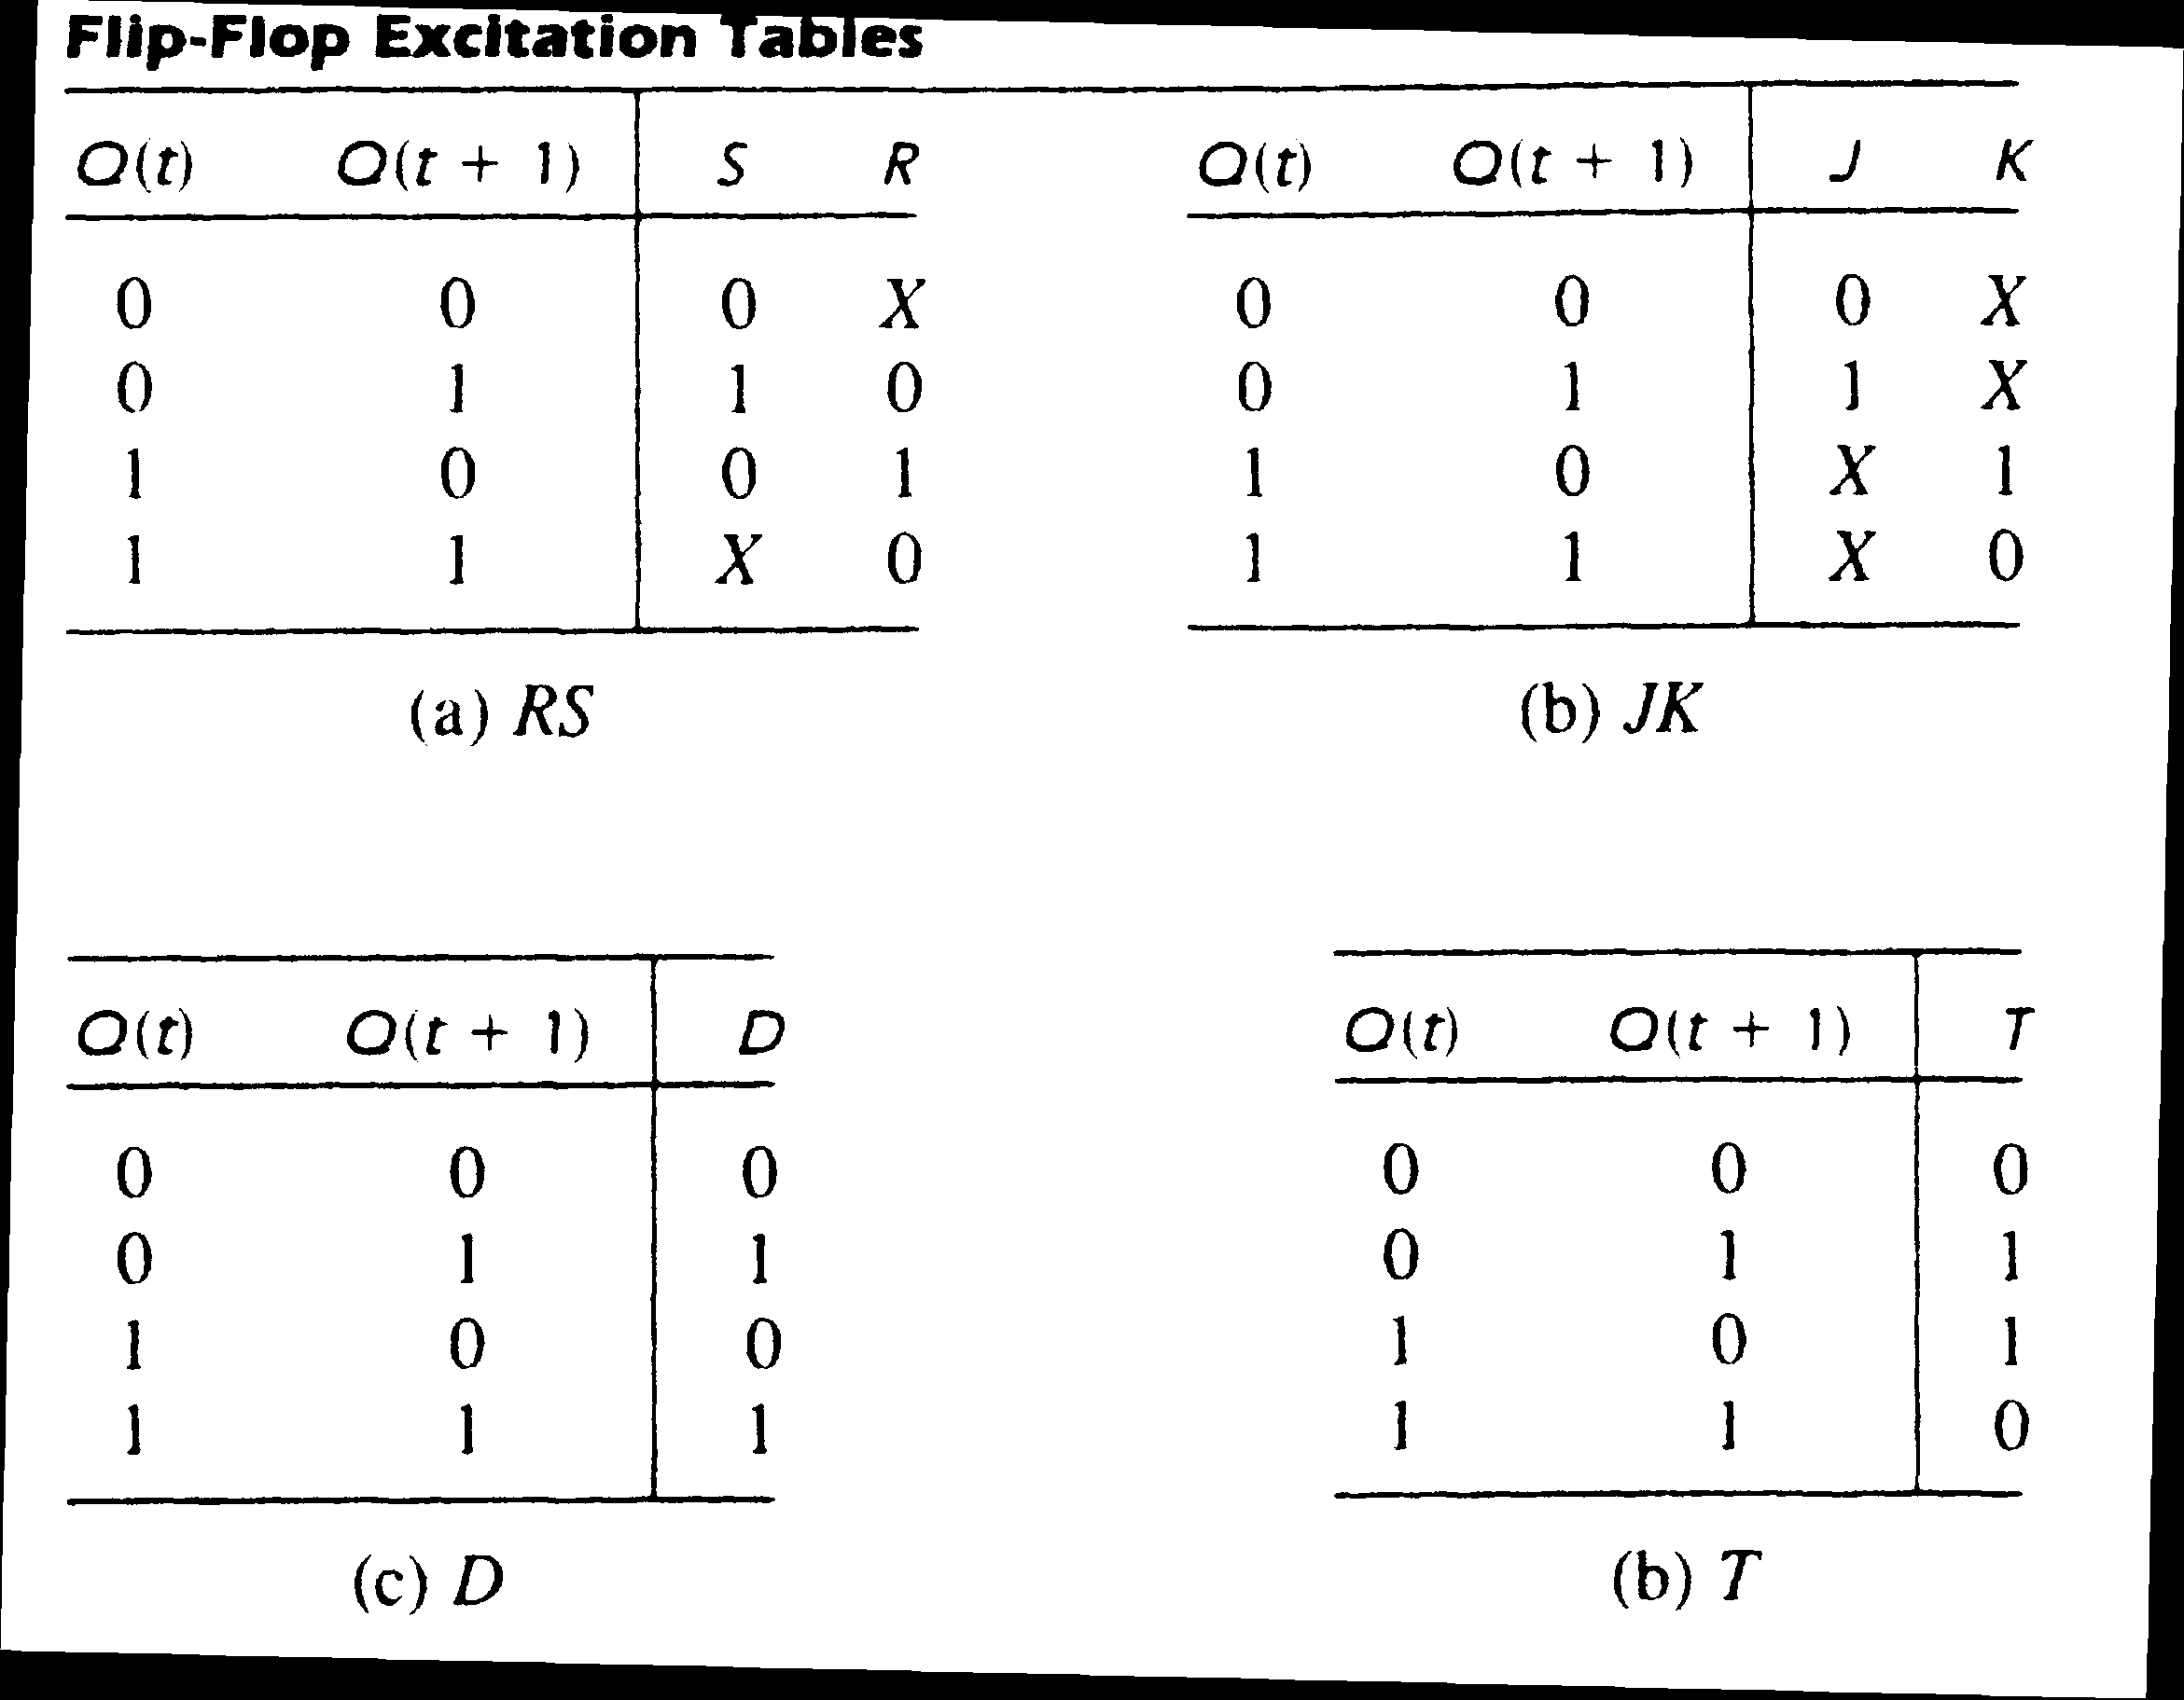

Question I (5 marks)

Tick (√ ) the correct answer for each of the following questions (½ mark each):

- The largest binary number which can be represented with n bits is given by _________..

    - 2^{n – 1} number of 1s
    - n – 1 number of 1s
    - n number of 1s √
    - 2^{n} number of 1s

- Using four bits, the magnitude of the largest positive number which can be represented in sign magnitude representation is __________.

- 6
- 7 √
iii. 3
iv. 5

3) Assigning low voltages to logic 0 and high voltages to logic 1 is called __________.

i. conditional logic
ii. positive logic √
iii. negative logic
iv. verilog logic

4) If $F(x,y,z)=\sum{(0,2,5,6)}$then $\overset{\text{__}}{F}$ will be given by ______________.

- $\sum{(0,1,2,3,4,5,6,7)}$
- $\prod{(0,2,5,6)}$ √
- $\prod{(1,3,4,7)}$
- $\prod{(0,1,2,3,4,5,6,7)}$

5) Dual of XOR function is equivalent to ____________.

i. XOR function
ii. XNOR function √
iii. NAND function
iv. NOR function

6) All sequential circuits must have one input labeled as ___________.

- Combinational input
- Control input
- Up/down input
- Clock input √

7) In Verilog-HDL, which of the following statements is not correct for a magnitude comparator circuit:

- assign A_lessthan_B= (A<B);
- assign A_greaterthan_B=(A >B);
- assign A_equalto_B=(A==B);
- assign A_equalto_B=(A=B); √

- ROM is an abbreviation for ____________ circuit.

- Read-Write Memory
- Read Only Memory √
- Read Once Memory
- Read Out Memory

- A PLD consisting of programmable AND array and programmable OR array is called ________.

- PROM
- PLA √
- PAL
- EPROM

10) A RAM consisting of 1K words will have __________ number of address lines.

i. 1000
ii. 1024 x 8
- 10 √
- 1024

Question II (5 marks)

a) (3 marks) An 8x1 multiplexer has inputs A, B, and C, connected to the selection inputs s₂,s₁,s₀, respectively. The data inputs I₀ through I₇ are connected as follows: I₁ = I₂ = 0, I₃ = I₇ =1, I₄ = I₅ = D, I₀ = I₆ = D’ . Determine the Boolean function F(A,B,C,D) that the multiplexer implements.

 | I₀ | I₁ | I₂ | I₃ | I₄ | I₅ | I₆ | I₇
D’ | 0 | 2 | 4 | 6 | 8 | 10 | 12 | 14
D | 1 | 3 | 5 | 7 | 9 | 11 | 13 | 15
 | D’ | 0 | 0 | 1 | D | D | D’ | 1

$$F(A,B,C,D)=\sum{(0,6,7,9,\text{11},\text{12},\text{14},\text{15})}$$

b) (2 marks) Give truth table of a full-subtractor circuit with three inputs x, y, B_{in} and two outputs Diff and B_{out} . The circuit subtracts x – y – Bin where B_{in} is the input borrow, B_{out} is the output borrow, and Diff is the difference.

x | y | Bin | Diff | Bout
0 | 0 | 0 | 0 | 0
0 | 0 | 1 | 1 | 1
0 | 1 | 0 | 1 | 1
0 | 1 | 1 | 0 | 1
1 | 0 | 0 | 1 | 0
1 | 0 | 1 | 0 | 0
1 | 1 | 0 | 0 | 0
1 | 1 | 1 | 1 | 1

Question III (5 marks)

a) (1 mark) Following is the verilog-HDL description of a circuit. Describe the function of the circuit
IN ONLY ONE WORD.

output y;
input a, b, c, d;
table
// a b c d : y
0 0 0 0 : 0;
0 0 0 1 : 0;
0 0 1 0 : 0;
0 0 1 1 : 0;
0 1 0 0 : 0;
0 1 0 1 : 0;
0 1 1 0 : 0;
0 1 1 1 : 1;
1 0 0 0 : 0;
1 0 0 1 : 0;
1 0 1 0 : 0;
1 0 1 1 : 1;
1 1 0 0 : 0;
1 1 0 1 : 1;
1 1 1 0 : 1;
1 1 1 1 : 1;
endtable

Write your answer here: This circuit is a MAJORITY circuit.

b) (4 marks) In the following circuit (Figure 1) the decoder (DCD) has two inputs and four (active high) outputs. The three multiplexers (MUX) each have two select inputs (shown on top of the box) and an active high enable input (shown on the bottom of the box). Inputs A, B, C, D are select inputs; inputs N through Z are data inputs. Fill in the following truth table for the circuit giving the value of output F for each of the 16 possible select combinations.

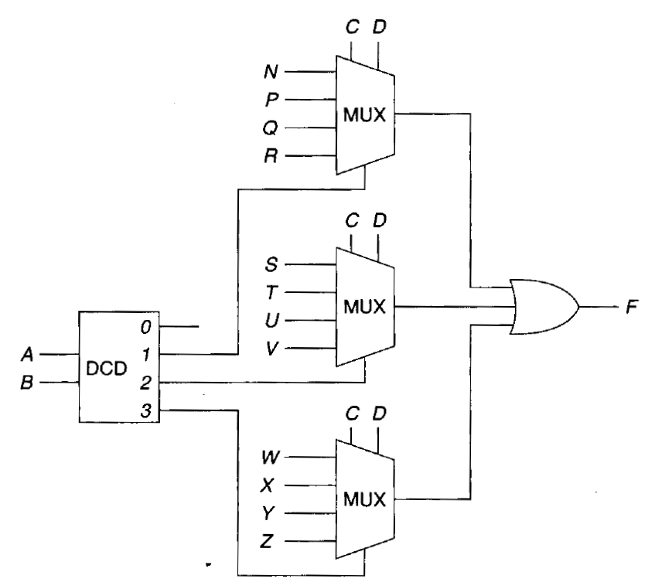

Figure 1

A | B | C | D | F
0 | 0 | 0 | 0 | 0
0 | 0 | 0 | 1 | 0
0 | 0 | 1 | 0 | 0
0 | 0 | 1 | 1 | 0
0 | 1 | 0 | 0 | N
0 | 1 | 0 | 1 | P
0 | 1 | 1 | 0 | Q
0 | 1 | 1 | 1 | R
1 | 0 | 0 | 0 | S
1 | 0 | 0 | 1 | T
1 | 0 | 1 | 0 | U
1 | 0 | 1 | 1 | V
1 | 1 | 0 | 0 | W
1 | 1 | 0 | 1 | X
1 | 1 | 1 | 0 | Y
1 | 1 | 1 | 1 | Z

Question IV (10 marks)

a) (3 marks) Give block diagram of a 3-bit shift register for serial data transmission. The diagram should indicate the following connections:

- Shifts data right
- Uses D flip-flops
- Serial input and serial output lines
- Negative edge triggered clock
- Clear (reset) which enables at logic 1.
- Set (preset) which enables at logic 0.

ANSWER ONLY IN THE BLOCK GIVEN BELOW:

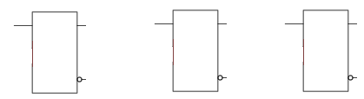

b) (3 marks) The functions X and Y have been implemented by a programmable logic device and the connections are as shown in Figure 2.
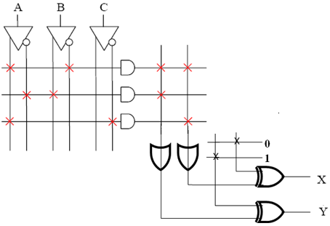
Figure 2

ANSWER THE FOLLOWING QUESTIONS ONLY IN THE BLOCK BELOW:

- What is the name of this PLD device .………………………………………………..

- Write the Boolean expression for the function X …………………………………….

- Write the Boolean expression for the function Y……………………………………

c) (4 marks) Refer to Figure 3 given below:
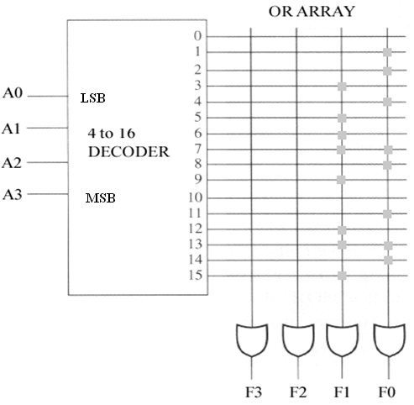
Figure 3

ANSWER ONLY IN THE BLOCK GIVEN BELOW:

1) The name of the device is …………………………………………………………….

2) The size of the device is ………………………………………………………………

3) If address lines(A3 A2 A1 A0) = (1101), what will be the outputs (F3 F2 F1 F0) ……………………………………………………………………………….

4) If address lines(A3 A2 A1 A0) = (0001), what will be the outputs (F3 F2 F1 F0) ……………………………………………………………………………….

Question V (15 marks)

a) (5 marks) Consider the following state-transition diagram (see Figure 4) which is to be implemented as a clocked, synchronous sequential circuit. In the figure * indicates don’t care, and a, b, c, d represent four states in 00, 01, 10, 11 order respectively.

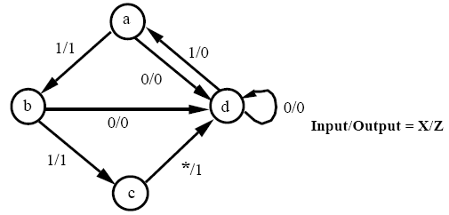
Figure 4

ANSWER IN THE BLOCK GIVEN BELOW:
Construct a state transition table for the circuit in terms of input X, present-state (PS), output Z, and next-state (NS).

b) (10 marks) Design a sequential circuit which automatically switches in sequence: 1 → 3 → 0 → 2 → 1. Use minimum number of logic gates (AND, OR, NAND, NOR, XOR, XNOR, or inverters) and positive-edge-triggered JK flip-flops only. Show all steps including state diagram, state transition table, flip-flops input and output equations, and logic diagram. Test your circuit to ensure that your design is correct.

=========================== THE END ============================

