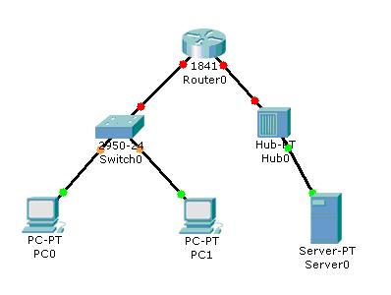
- Is the diagram shows peer-to-peer NW or client server NW? Why? ( 1 mark)
It’s peer-to-peer NW. Because it connected to creat a network with using a network device such as: Hub. Also, it consists of using wired connections.
2. you are giving the following information
Device Name | MAC | IP
PC0 | AA:BC:DF:12:A5 | 80.3.52.100
PC1 | BB:BC:DF:12:A5 | 80.3.600.2
Server0 | CY:BC:DF:12:A5 | 172.5.2.1

- Is all the Giving addresses for the above devices are valid? Why? ( 2marks)
It’s not valid because all MAC address is wrong. It should be 6 parts not 5. However IP has 5 parts. For example AA:BC:DF:DF:12:A5 has 6 parts not 5 parts.
- According to the diagram and the giving information in the table. Is all the devices belong to one network? Why (give 2 reasons)? ( 2 marks)
Yes one Network, because it has on Router that connects a local area network.

3. Which method is used to set IP information for the following devices( total 2marks each 0.25 mark)
a. Server, Static
b. Router Static
c. PC0 DHCP
d. PC1 DHCP
4. Server0 is an email server, if PC0 want to send a request to server0 to view e-mails. Explain the communication between PC0 and server0 using OSI model.( 3 marks)
- In OSI model there are 7 layers to organize the tasks.
*In the first three layers (Application, Presentation, session) the PC0 write the e-mails (DATA).
e-mail

*In the fourth layer (Transport) the e-mails (DATA) will cut it in small pieces.
1
2
3
* In the fifth layer (Network) the small pieces will write the IP Address and e-mail (Data).Each piece will have IP Address and e-mail (Data).
IP | e-mail
IP | e-mail
IP | e-mail
*In the seventh layer (Data Link) the e-mail will nearly be completed to send a request. It will be showing a link and the link has MAC Address, IP Address, Data.
MAC | IP | e-mail

*In the final layer (Physical Layer) shows the e-mail and the computer understand the e-mail with binary numbers (bits)
(011011110110111) bits

