1. Which of the following statements is incorrect?
a) Ionic bonding results from the transfer of electrons from one atom to another.
b) Dipole moments result from the unequal distribution of electrons in a molecule.
c) The electrons in a polar bond are found nearer to the more electronegative element.
d) A molecule with very polar bonds can be nonpolar.
e) Linear molecules cannot have a net dipole moment.
Ans: e) Linear molecules cannot have a net dipole moment. Page: 8.1,3
2. Atoms having greatly differing electronegativities are expected to form:
a) no bonds
b) polar covalent bonds
c) nonpolar covalent bonds
d) ionic bonds
e) covalent bonds
Ans: d) ionic bonds Page: 8:1,2
3. Choose the compound with the most ionic bond.
a) LiCl
b) KF
c) NaCl
d) LiF
e) KCl
Ans: b) KF Page: 8.2
4. Atoms with very similar electronegativity values are expected to form
a) no bonds.
b) covalent bonds.
c) triple bonds.
d) ionic bonds.
e) none of these
ANS: b) covalent bonds PAGE: 8.1,2
5. Which of the following bonds is least polar?
a) C—O
b) H—C
c) S—Cl
d) Br—Br
e) They are all nonpolar.
ANS: d) Br—Br Page: 8.2
6. For the elements Rb, F, and O, the order of increasing electronegativity is:
a) Rb < F < O
b) Rb < O < F
c) O < F < Rb
d) F < Rb < O
e) None of these
ANS: b) Rb < O < F PAGE: 8.2
7. For the elements Cs, F, and Cl, the order of increasing electronegativity is:
a) F < Cl < Cs
b) Cs < Cl < F
c) Cl < Cs < F
d) F < Cs < Cl
e) None of these
ANS: b) Cs < Cl < F PAGE: 8.2
8. In the gaseous phase, which of the following diatomic molecules would be the most polar?
a) CsF
b) CsCl
c) NaCl
d) NaF
e) LiF
ANS: a) CsF PAGE: 8.2
9. Based on electronegativities, which of the following would you expect to be most ionic?
a) N2
b) CaF2
c) CO2
d) CH4
e) CF4
ANS: b) CaF2 PAGE: 8.2
10. In which case is the bond polarity incorrect?
a) δ+H–Fδ–
b) δ+K–Oδ–
c) δ+Mg–Hδ–
d) δ+Cl–Iδ–
e) δ+Si–Sδ–
ANS: d) δ+Cl–Iδ– PAGE: 8.2
11. Which of the following groups contains no ionic compounds?
a) HCN, NO2, Ca(NO3)2
b) PCl5, LiBr, Zn(OH)2
c) KOH, CCl4, SF4
d) NaH, CaF2, NaNH2
e) CH2O, H2S, NH3
ANS: e) CH2O, H2S, NH3 PAGE: 8.2
12. In which pair do both compounds exhibit predominantly ionic bonding?
a) PCl5 and HF
b) Na2SO3 and BH3
c) KI and O3
d) NaF and H2O
e) RbCl and CaO
ANS: e) RbCl and CaO PAGE: 8.2
13. Metals typically have _______ electronegativity values.
a) high
b) low
c) negative
d) no
e) two of these
ANS: b) low PAGE: 8.2
14. The electron pair in a C-F bond could be considered
a) closer to C because carbon has a larger radius and thus exerts greater control over the shared electron pair.
b) closer to F because fluorine has a higher electronegativity than carbon.
c) closer to C because carbon has a lower electronegativity than fluorine.
d) an inadequate model since the bond is ionic.
e) centrally located directly between the C and F.
ANS: b) closer to F because fluorine has a higher electronegativity than carbon. PAGE: 8.2
15. Based on electronegativity differences, which of the following is most likely to be ionic?
a) BaF2
b) Cl2
c) NH3
d) NO3
e) CH4
ANS: a) BaF2 PAGE: 8.2
16. What is the correct order of the following bonds in terms of decreasing polarity?
a) N-Cl, P-Cl, As-Cl
b) P-Cl, N-Cl, As-Cl
c) As-Cl, N-Cl, P-Cl
d) P-Cl, As-Cl, N-Cl
e) As-Cl, P-Cl, N-Cl
ANS: e) As-Cl, P-Cl, N-Cl PAGE: 8.2
17. Which of the following bonds would be the most polar without being considered ionic?
a) Mg-O
b) C-O
c) O-O
d) Si-O
e) N-O
ANS: d) Si-O PAGE: 8.2
18. Which of the following bonds would be the least polar yet still be considered polar covalent?
a) Mg-O
b) C-O
c) O-O
d) Si-O
e) N-O
ANS: e) N-O PAGE: 8.2
19. How many of the following molecules possess dipole moments?
BH3, CH4, PCl5, H2O, HF, H2
a) 1
b) 2
c) 3
d) 4
e) 5
ANS: b) 2 PAGE: 8.3,13
20. Which of the following molecules has a dipole moment?
a) CH4
b) CCl4
c) CO2
d) SO3
e) none of these
ANS: d) SO3 PAGE: 8.3,13
21. Select the molecule among the following that has a dipole moment.
a) CO2
b) SeO3
c) XeF4
d) SF4
e) BeCl2
ANS: d) SF4 PAGE: 8.3,13
22. Which of the following molecules (or ions) has a dipole moment?
a) CO2
b) CO
c) NH
d) PF3
e) two of them do
ANS: d) PF3 PAGE: 8.3, 13
23. Which of the following molecules has a dipole moment?
a) BCl3
b) SiCl4
c) PCl3
d) Cl2
e) none of these
ANS: c) PCl3 PAGE: 8.3,13
24. Which of the following molecules has no dipole moment?
a) CO2
b) NH3
c) H2O
d) all
e) none
ANS: a) CO2 PAGE: 8.3,13
25. Choose the statement that best describes the PbCl4 molecule in the gas phase.
a) The bond angles are all about 109°.
b) The molecule is polar.
c) The molecule has a dipole moment.
d) The bonds are nonpolar.
e) a, b, and c
ANS: a) The bond angles are all about 109°. PAGE: 8.3,13
26. Which of the following has a zero dipole moment?
a) NH3
b) NO2
c) PF5
d) SO2
e) HCN
ANS: c) PF5 PAGE: 8.3,13
27. Which of the following has the smallest radius?
a) Br–
b) S2-
c) Xe
d) Ca2+
e) Kr
ANS: d) Ca2+ PAGE: 8.4
28. Which of these is an isoelectronic series?
a) Na+, K+, Rb+, Cs+
b) K+, Ca2+, Ar, S2-
c) Na+, Mg2+, S2-, Cl-
d) Li, Be, B, C
e) none of these (a-d)
ANS: b) K+, Ca2+, Ar, S2- PAGE: 8.4

29. Which of the following has the smallest radius?
a) K+
b) Cl–
c) Rb+
d) S2–
e) Ar
ANS: a) K+ PAGE: 8.4
30. Which of the following ionic compounds has the smallest lattice energy, i.e., the lattice energy least favorable to a stable lattice?
a) LiF
b) CsI
c) NaCl
d) BaO
e) MgO
ANS: b) CsI PAGE: 8.5
31. Calculate the lattice energy for LiF(s) given the following:
sublimation energy for Li(s) +166 kJ/mol
ΔHf for F(g) +77 kJ/mol
first ionization energy of Li(g) +520. kJ/mol
electron affinity of F(g) –328 kJ/mol
enthalpy of formation of LiF(s) –617 kJ/mol
a) 285 kJ/mol
b) –650. kJ/mol
c) 800. kJ/mol
d) –1047 kJ/mol
e) None of these
ANS: d) –1047 kJ/mol PAGE: 8.5
32. When electrons in a molecule are not found between a pair of atoms but move throughout the molecule, this is called
a) ionic bonding.
b) covalent bonding.
c) polar covalent bonding.
d) delocalization of the electrons.
e) a dipole moment.
ANS: d) delocalization of the electrons. PAGE: 8.1,7

33. Which of the following statements concerning lattice energy is false?
a) It is often defined as the energy released when an ionic solid forms from its ions.
b) MgO has a larger lattice energy than NaF.
c) The lattice energy for a solid with 2+ and 2– ions should be two times that for a solid with 1+ and 1– ions.
d) MgO has a larger lattice energy than LiF.
e) All of these are true.
ANS: c) The lattice energy for a solid with 2+ and 2– ions should be two times that for a solid with 1+ and 1– ions. PAGE: 8.5
34. Which of the following pairs is isoelectronic?
a) Li+ and K+
b) Na+ and Ne
c) I– and Cl–
d) S2– and Ne
e) Al3+ and B3+
ANS: b) Na+ and Ne PAGE: 8.4
35. Which of the following arrangements is in order of increasing size?
a) Ga3+ > Ca2+ > K+ > Cl– > S2–
b) S2– > Cl– > K+ > Ca2+ > Ga3+
c) Ga3+ > S2– > Ca2+ > Cl– > K+
d) Ga3+ > Ca2+ > S2– > Cl– > K+
e) Ga3+ > Ca2+ > S2– > K+ > Cl–
ANS: a) Ga3+ > Ca2+ > K+ > Cl– > S2– PAGE: 8.4
36. Which of the following types of molecules has a dipole moment (when polar bonds are present)?
a) linear molecules with two identical bonds
b) tetrahedral molecules (four identical bonds equally spaced)
c) trigonal pyramid molecules (three identical bonds)
d) trigonal planar molecules (three identical bonds equally spaced)
e) None has a dipole moment.
ANS: c) trigonal pyramid molecules (three identical bonds) PAGE: 8.3

37. Given the following information:
Li(s) → Li(g) heat of sublimation of Li(s) = 166 kJ/mol
HCl(g) → H(g) + Cl(g) bond energy of HCl = 427 kJ/mol
Li(g) → Li+(g) + e– ionization energy of Li(g) = 520. kJ/mol
Cl(g) + e– → Cl–(g) electron affinity of Cl(g) = –349 kJ/mol
Li+(g) + Cl–(g) → LiCl(s) lattice energy of LiCl(s) = –829 kJ/mol
H2(g) → 2H(g) bond energy of H2 = 432 kJ/mol
calculate the net change in energy for the reaction 2Li(s) + 2HCl(g) → 2LiCl(s) + H2(g)
a) 363 kJ
b) –562 kJ
c) –179 kJ
d) –73 kJ
e) None of these
ANS: b) –562 kJ PAGE: 8.5
38. The first electron affinity value for oxygen is _______ and the second electron affinity value is ________.
a) unfavorable (endothermic), favorable (exothermic)
b) unfavorable (endothermic), unfavorable (endothermic)
c) favorable (exothermic), favorable (exothermic)
d) favorable (exothermic), unfavorable (endothermic)
e) More information is needed.
ANS: d) favorable (exothermic), unfavorable (endothermic) PAGE: 8.5
39. Choose the molecule with the strongest bond.
a) F2
b) Cl2
c) Br2
d) I2
e) All are equal.
ANS: b) Cl2 PAGE: 8.8
40. Choose the molecule with the strongest bond.
a) HF
b) HCl
c) HBr
d) HI
e) All are equal.
ANS: a) HF PAGE: 8.8

41. Choose the molecule with the strongest bond.
a) CH4
b) H2O
c) NH3
d) HF
e) All are equal
ANS: d) HF PAGE: 8.8
42. Which of the following molecules exhibits the greatest bond energy?
a) F2
b) Cl2
c) Br2
d) I2
e) all the same
ANS: b) Cl2 PAGE: 8.8
43. As the number of bonds between two carbon atoms increases, which one of the following decreases?
a) number of electrons between the carbon atoms
b) bond energy
c) bond length
d) all of these
e) none of these
ANS: c) bond length PAGE: 8.8
44. Using the following bond energies
Bond Bond Energy (kJ/mol)
C≡C 839
C–H 413
O=O 495
C=O 799
O–H 467
estimate the heat of combustion for one mole of acetylene:
C2H2(g) + (5/2)O2(g) → 2CO2(g) + H2O(g)
a) 1228 kJ
b) –1228 kJ
c) –447 kJ
d) +447 kJ
e) +365 kJ
ANS: b) –1228 kJ PAGE: 8.8
45. Which of the following species would be expected to have the lowest ionization energy?
a) F-
b) Ne
c) O2-
d) Mg2+
e) Na+
ANS: c) O2- PAGE: 8.4
46. Which of the following has the smallest radius?
a) F-
b) Ne
c) O2-
d) Mg2+
e) Na+
ANS: d) Mg2+ PAGE: 8.4
47. Which of the following ionic compounds has the largest lattice energy (the lattice energy most favorable to a stable lattice)?
a) BaO
b) BeO
c) CsI
d) NaBr
e) BaS
ANS: b) BeO PAGE: 8.5
48. In which of the following compounds does the bond between the central atom and bromine have the greatest ionic character?
a) LiBr
b) KBr
c) SeBr2
d) AsBr2
e) CaBr2
ANS: b) KBr PAGE: 8.2
49. Which of the following species is best described by drawing resonance structures?
a) PH3
b) NH4+
c) O3
d) SO3-
e) HCN
ANS: c) O3 PAGE: 8.12
50. Using the following data reactions
ΔH° (kJ)
H2(g) + Cl2(g) → 2HCl(g) –184
H2(g) → 2H(g) 432
Cl2(g) → 2Cl(g) 239
calculate the energy of an H–Cl bond.
a) 770 kJ
b) 856 kJ
c) 518 kJ
d) 326 kJ
e) 428 kJ
ANS: e) 428 kJ PAGE: 6.3,8.8
51. Given the following bond energies
C–C 347 kJ/mol
C=C 614 kJ/mol
C–O 358 kJ/mol
C=O 799 kJ/mol
C–H 413 kJ/mol
O–H 463 kJ/mol
O–O 146 kJ/mol
estimate ΔH for the reaction H2O2 + CH3OH → H2CO + 2H2O.
a) –345 kJ
b) –199 kJ
c) –105 kJ
d) +199 kJ
e) +345 kJ
ANS: a) –345 kJ PAGE: 8.8

52. Given the following information
N2 bond energy = 941 kJ/mol
F2 bond energy = 154 kJ/mol
N2(g) + F2(g) → NF3(g) ΔH° = –103 kJ/mol
calculate the N–F bond energy.
a) 113 kJ/mol
b) 268 kJ/mol
c) 317 kJ/mol
d) 66 kJ/mol
e) none of these
ANS: b) 268 kJ/mol PAGE: 8.8
53–55. Using the following electronegativity values
C 2.5 Cl 3.2
H 2.2 N 3.0
O 3.4
select from the following group the molecule that fits the given statement:
a) CH3CHO
b) CO2
c) CH3Cl
d) C2H6
e) none
53. This molecule contains a carbon atom with trigonal planar geometry.
ANS: a) CH3CHO PAGE: 8.13
54. This molecule is the most polar.
ANS: a) CH3CHO PAGE: 8.3,13
55. This molecule shows the smallest number of lone pairs in its Lewis structure.
ANS: d) C2H6 PAGE: 8.10
56. As indicated by Lewis structures, which of the following would probably not exist as a stable molecule?
a) CH3OH
b) CH2O
c) CH3O
d) C2H2
e) C3H4
ANS: c) CH3O PAGE: 8.10,11
57. Which of the following molecules is non-polar overall?
a) SF4
b) SF2
c) CCl4
d) H2S
e) OCl2
ANS: c) CCl4 PAGE: 8.3,13
58. Select the best Lewis structure for acetone, CH3COCH3.
a) 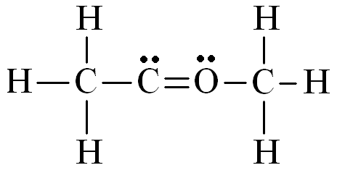
b) 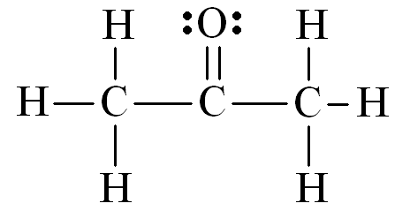
c) 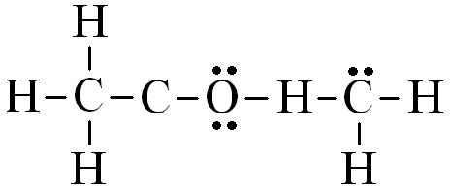
d) 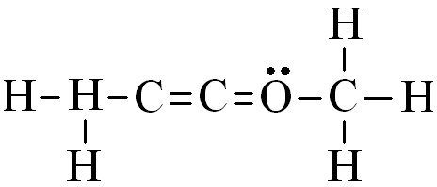
e) 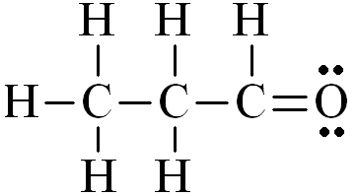
ANS: b) PAGE: 8.10,12

59. Which of the following is the correct order for molecules from most to least polar?
a) CH4 > CF2Cl2 > CF2H2 > CCl4 > CCl2H2
b) CH4 > CF2H2 > CF2Cl2 > CCl4 > CCl2H2
c) CF2Cl2 > CF2H2 > CCl2H2 > CH4 = CCl4
d) CF2H2 > CCl2H2 > CF2Cl2 > CH4 = CCl4
e) CF2Cl2 > CF2H2 > CCl4 > CCl2H2 > CH4
ANS: d) CF2H2 > CCl2H2 > CF2Cl2 > CH4 = CCl4 PAGES: 8.1–3,13
60. Of the following, which molecule has the largest bond angle?
a) O3
b) OF2
c) HCN
d) H2O
e) More than one of these have equally large bond angles.
ANS: c) HCN PAGE: 8.13
61. According to the VSEPR model, the arrangement of electron pairs around NH3 and CH4 are
a) different because in each case there are a different number of atoms around the central atom.
b) different because in each case there are a different number of electron pairs around the central atom.
c) the same because both nitrogen and carbon are both in the second period.
d) the same because in each case there are the same number of electron pairs around the central atom.
e) different or the same, depending on the conditions leading to maximum repulsion.
ANS: d) the same because in each case there are the same number of electron pairs around the central atom. PAGE: 8.13
62. The Cl–Kr–Cl bond angle in KrCl4 is closest to
a) 90°
b) 109°
c) 120°
d) 150°
e) 360°
ANS: a) 90° PAGE: 8.13

63. Which of the following atoms cannot exceed the octet rule in a molecule?
a) N
b) S
c) P
d) I
e) All of the atoms (a-d) can exceed the octet rule.
ANS: a) N PAGE: 8.11
64. In the cyanide ion (CN–), the nitrogen has a formal charge of
a) -2
b) -1
c) 0
d) 2
e) 2
ANS: c) 0 PAGE: 8.10-12
65. Which has the larger N–O bond length, NO2– or NO3–?
a) NO2–
b) NO3–
c) The bond lengths are the same.
d) More information is needed.
e) None of these (a-d)
ANS: b) NO3– PAGE: 8.8,10–12
66. How many of the following molecules—SF2, SF4, SF6, SiO2—are polar?
a) 0
b) 1
c) 2
d) 3
e) 4
ANS: c) 2 PAGE: 8.1–3,13
67. Which of the following exhibits resonance?
a) CH4
b) PCl5
c) H2O
d) NO2
e) At least two of the molecules (a-d) exhibit resonance.
ANS: d) NO2 PAGE: 8.12

68. How many resonance structures can be drawn for the molecule O3?
a) 1
b) 2
c) 3
d) 4
e) 5
ANS: b) 2 PAGES: 8.10, 12
69. As indicated by Lewis structures, which of the following species could probably not exist as a stable molecule?
a) NH3
b) N2H2
c) N2H4
d) N2H6
e) N2O4
ANS: d) N2H6 PAGE: 8.10,11
70. Choose the electron dot formula that most accurately describes the bonding in CS2. (Hint: Consider formal charges.)
a) 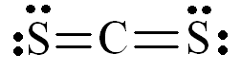
b) 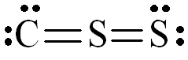
c) 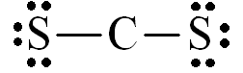
d) 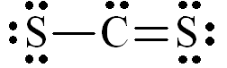
e) 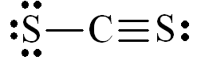

ANS: a) PAGE: 8.10, 12
71. Which of the following has a Lewis structure most like that of CO32–?
a) CO2
b) SO32–
c) NO3–
d) O3
e) NO2
ANS: c) NO3– PAGE: 8.10

72. Which of the following is not a valid resonance structure for N3–?
a) 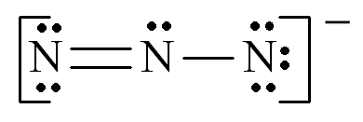
b) 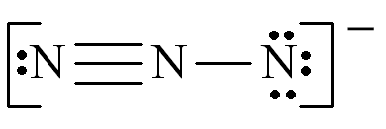
c) 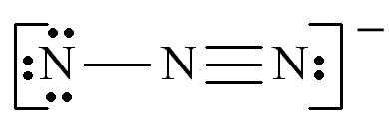
d) 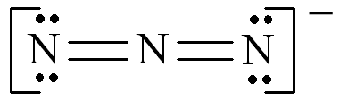
e) all are correct all are correct
ANS: a) PAGE: 8.10, 12

73. In the Lewis structure for elemental nitrogen there is (are)
a) a single bond between the nitrogens.
b) a double bond between the nitrogens.
c) a triple bond between the nitrogens.
d) three unpaired electrons.
e) none of these.
ANS: c) a triple bond between the nitrogens. PAGE: 8.10
74. Complete the Lewis structure for the molecule:
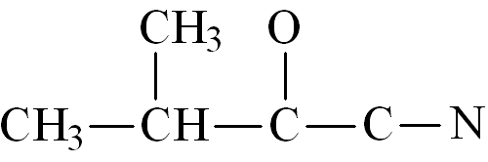
This molecule has __________ single bonds and __________ multiple bonds.
a) 4, 2
b) 6, 3
c) 11, 5
d) 11, 2
e) 13, 0
ANS: d) 11, 2 PAGE: 8.10
75–77. Draw the Lewis structures of the molecules below and use them to answer the following questions:
I. BH3
II. NO2
III. SF6
IV. O3
V. PCl5
75. Which of the molecules obeys the octet rule?
a) I
b) II
c) III
d) IV
e) V
ANS: d) IV PAGE: 8.10,11
76. How many of the molecules have no dipole moment?
a) 1
b) 2
c) 3
d) 4
e) they are all polar
ANS: c) 3 PAGE: 8.3,13
77. Which of these molecules show resonance?
a) I, II
b) II, IV
c) II, V
d) III, IV
e) III, V
ANS: b) II, IV PAGE: 8.12
78. The force between two bodies having identical electric charges
a) is a force of repulsion.
b) is a force of repulsion if the charges are negative, and one of attraction if they are positive.
c) increases as the bodies are moved farther apart.
d) is independent of the distance between them.
e) is directly proportional to the distance between them.
ANS: a) is a force of repulsion. PAGE: 8.1
79–81. Consider the compound crotonaldehyde, whose skeleton is
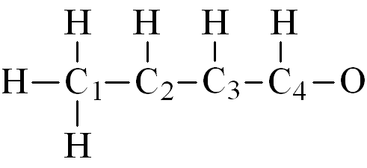
79. How many electrons must be shown in the Lewis structure of this molecule?
a) 12
b) 18
c) 24
d) 28
e) 32
ANS: d) 28 PAGE: 8.10
80. How many nonbonding electrons appear in the Lewis structure of this molecule?
a) 2
b) 4
c) 6
d) 8
e) 10
ANS: b) 4 PAGE: 8.10
81. Which carbon in this molecule has tetrahedral bonding?
a) 1
b) 2
c) 3
d) 4
e) all
ANS: a) 1 PAGE: 8.13
82. Which of the following molecules contains a double bond?
a) CO2
b) NH3
c) H2O
d) all
e) none
ANS: a) CO2 PAGE: 8.10
83. When molten sulfur reacts with chlorine gas, a vile smelling orange liquid forms that is found to have the empirical formula SCl. Which of the following could be the correct Lewis structure for this compound?
a) 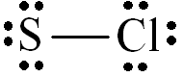
b) 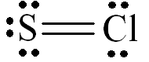
c) 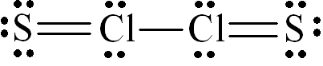
d) 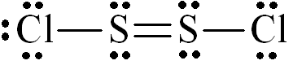
e) 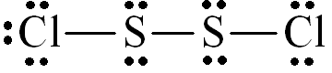
ANS: e) PAGE: 8.10
84–85. Given the following Lewis structure:
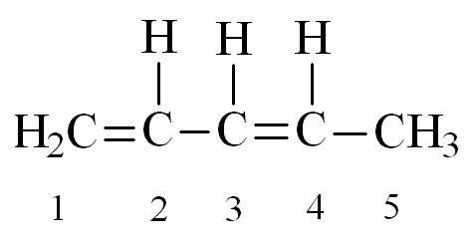
84. How many unshared pairs of electrons are present in this molecule?
a) 0
b) 1
c) 2
d) 3
e) 4
ANS: a) 0 PAGE: 8.10
85. How many electrons are shared between carbons 1 and 2?
a) 0
b) 2
c) 4
d) 6
e) 8
ANS: c) 4 PAGE: 8.10
86. Which of the following compounds contains only one unshared pair of valence electrons?
a) NH3
b) H2O
c) CH4
d) NaCl
e) BeF3
ANS: a) NH3 PAGE: 8.10,11
87. In the reaction between magnesium and sulfur, the magnesium atoms
a) become anions.
b) become cations.
c) become part of polyatomic ions.
d) share electrons with sulfur.
ANS: b) become cations. PAGE: 8.5
88. The Lewis structure for H3BO3 is
a) 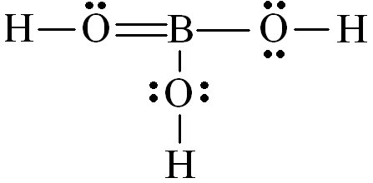
b) 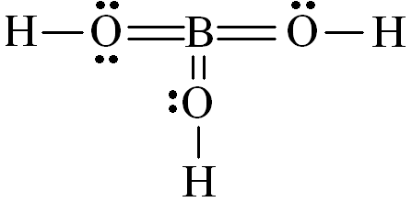
c) 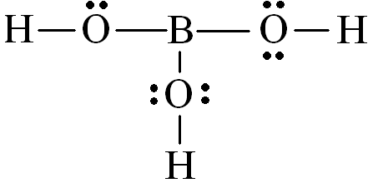
d) 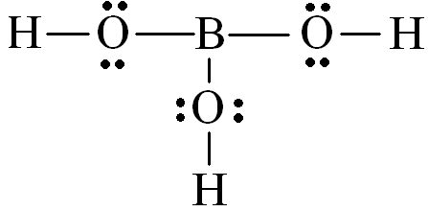
e) 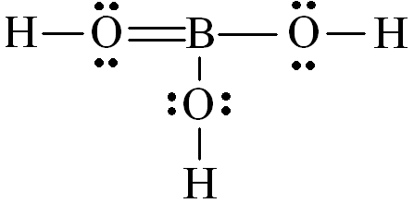
ANS: d) PAGE: 8.11
89. In the Lewis structure for ICl2–, how many lone pairs of electrons are around the central iodine atom?
a) 0
b) 1
c) 2
d) 3
e) 4
ANS: d) 3 PAGE: 8.11
90. In the Lewis structure for SF6, the central sulfur atom shares __________ electrons.
a) 4
b) 8
c) 10
d) 12
e) none of these, because SF6 is an ionic compound
ANS: d) 12 PAGE: 8.11
91–92. Consider the following molecules.
I. BF3
II. CHBr3 (C is the central atom)
III. Br2
IV. XeCl2
V. CO
VI. SF4
Select the molecule(s) that fit the given statement.
91. These molecules violate the octet rule.
a) I, II, IV
b) I, III, IV, VI
c) III, V, VI
d) I, IV, VI
e) I, II, IV, VI
ANS: d) I, IV, VI PAGE: 8.11
92. These molecules have a zero net dipole moment.
a) III, V
b) I, III, IV
c) III, IV, V
d) I, III, IV, VI
e) none of them
ANS: b) I, III, IV PAGE: 8.3,13
93. Which of the following Lewis structures best describes BF3?
a) 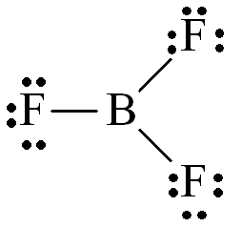
b) 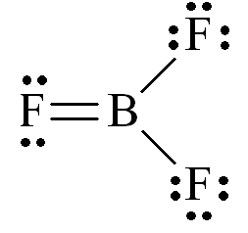
c) 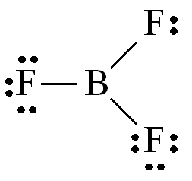
d) 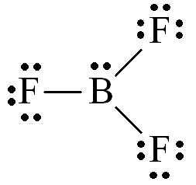
e) 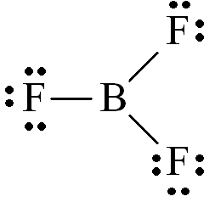
ANS: a) PAGE: 8.11
94. Which of the following molecules has a nonlinear structure?
a) XeF2
b) BeCl2
c) O3
d) CO2
e) N2O (central atom is N)
ANS: c) O3 PAGE: 8.13
95–100. Select the correct molecular structure for the given species from the choices below:
a) pyramidal
b) none of these
c) octahedral
d) trigonal planar
e) bent
95. SOCl2
ANS: a) pyramidal PAGE: 8.13
96. OF2
ANS: e) bent PAGE: 8.13
97. NCl3
ANS: a) pyramidal PAGE: 8.13
98. XeF5+
ANS: a) pyramidal PAGE: 8.13
99. BrF6+
ANS: c) octahedral PAGE: 8.13
100. BeF3-
ANS: d) trigonal planar PAGE: 8.13
101. The geometry of AsCl5 is
a) trigonal bipyramidal.
b) square pyramidal.
c) distorted tetrahedral.
d) octahedral.
e) none of these
ANS: a) trigonal pyramidal. PAGE: 8.13
102. How many of the following molecules or ions are linear?
NH3 NH4+ HCN CO2 NO2
a) 0
b) 1
c) 2
d) 3
e) 4
ANS: c) 2 PAGE: 8.13
103. The bond angles about the carbon atom in the formaldehyde molecule, H2C=O, are about:
a) 120°
b) 60°
c) 109°
d) 180°
c) 90°
ANS: a) 120° PAGE: 8.13
104. Which of the following molecules are nonlinear?
NO2–, C2H2, N3–, HCN, CO2, H2O2
a) C2H2, HCN
b) CO2, N3–
c) NO2–, H2O2
d) N3–, N2–
e) all are linear
ANS: c) NO2–, H2O2 PAGE: 8.13
105. What type of structure does the XeOF2 molecule have?
a) pyramidal
b) tetrahedral
c) T-shaped
d) trigonal planar
e) octahedral
ANS: c) T-shaped PAGE: 8.13
106. Which of the following species has a trigonal bipyramid structure?
a) NH3
b) IF5
c) I3–
d) PCl5
e) none of these
ANS: d) PCl5 PAGE: 8.13

107. The bond angle in H2Se is about:
a) 120°
b) 60°
c) 180°
d) 109°
e) 90°
ANS: d) 109° PAGE: 8.13
108. Which ion is planar?
a) NH4+
b) CO32–
c) SO32–
d) ClO3–
e) all are planar
ANS: b) CO32– PAGE: 8.13
109–116. Select the correct molecular structure for the given species from the choices below:
a) pyramidal
b) tetrahedral
c) square planar
d) octahedral
e) none of these
109. PF6–
ANS: d) octahedral PAGE: 8.13
110. PCl4+
ANS: b) tetrahedral PAGE: 8.13
111. XeF6
ANS: e) none of these PAGE: 8.13
112. NI3
ANS: a) pyramidal PAGE: 8.13
113. SiH4
ANS: b) tetrahedral PAGE: 8.13
114. ClO2
ANS: e) none of these PAGE: 8.13
115. IF4–
ANS: c) square planar PAGE: 8.13
116. SO32–
ANS: a) pyramidal PAGE: 8.13
117. Which of the following has an incomplete octet in its Lewis structure?
a) SO2
b) ICl
c) CO2
d) F2
e) NO
ANS: e) NO PAGE: 8.11
118–125. Select the correct molecular structure for the given species from the choices below:
a) linear
b) trigonal planar
c) tetrahedral
d) bent
e) none of these
118. H2O
ANS: d) bent PAGE: 8.13
119. CO2
ANS: a) linear PAGE: 8.13
120. BeCl2
ANS: a) linear PAGE: 8.13
121. SF4
ANS: e) none of these PAGE: 8.13
122. NO3–
ANS: b) trigonal planar PAGE: 8.13
123. I3–
ANS: a) linear PAGE: 8.13
124. PF5
ANS: e) none of these PAGE: 8.13
125. ClF
ANS: d) bent PAGE: 8.13
126. In the molecule XeF2, how many pairs of electrons surround Xe and what is the molecular geometry?
a) 4, bent
b) 4, pyramidal
c) 5, linear
d) 5, bent
e) 6, linear
ANS: c) 5, linear PAGE: 8.13
127. According to VSEPR theory, which of the following species has a square planar molecular structure?
a) TeBr4
b) BrF3
c) IF5
d) XeF4
e) SCl2
ANS: d) XeF4 PAGE: 8.13
128. How many of the following molecules have all of their atoms in the same plane?
H2C=CH2 F2O H2CO NH3 CO2 BeCl2 H2O2
a) 3
b) 4
c) 5
d) 6
e) 7
ANS: c) 5 PAGE: 8.13
129. Which of the following sets has elements with the most nearly identical atomic radii?
a) Cr, Mn, Fe, Co
b) Mg, Ca, Sr, Ba
c) Ne, Ar, Kr, Xe
d) Be, B, C, N
e) C, P, Se, I
ANS: a) Cr, Mn, Fe, Co PAGE: 8.7
130. When nonmetals chemically combine, they tend to form what type of bond?
ANS: covalent PAGE: 8.1,2
131. In spite of larger electronegativity differences between bonded atoms, BeCl2 has no dipole while SCl2 does. Explain fully.
ANS: See Sec. 8.3 of Zumdahl, Chemistry. PAGE: 8.3
132–135. For each of the following compounds:
a) draw the Lewis structure
b) give the shape of the molecule
c) indicate the polarity of the molecule
132. AlF3
ANS: a) 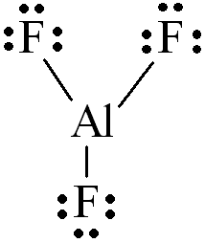
b) trigonal planar
c) nonpolar PAGE: 8.3,10,13
133. NH3
ANS: a) 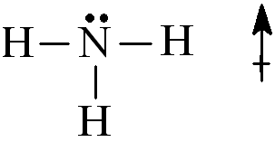
b) pyramidal
c) polar PAGE: 8.3,10,13
134. IC14–
ANS: a) 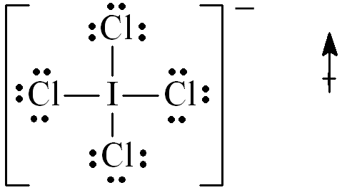

b) pyramidal
c) polar PAGE: 8.3,10,13
135. CBrI3
ANS: a) | 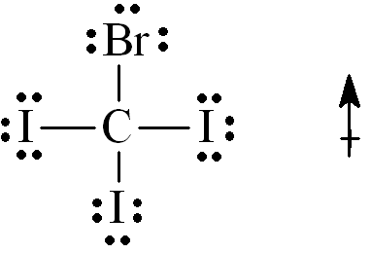
b) tetrahedral
c) polar PAGE: 8.3,10,13
136. When a metal reacts with a nonmetal a covalent bond is formed.
ANS: False PAGE: 8.1
137. A nonpolar covalent bond results from the unequal sharing of a pair of electrons between atoms in a molecule.
ANS: False PAGE: 8.1
138. The size in a series of isoelectronic ions increases as the nuclear charge increases.
ANS: False PAGE: 8.4
139. A double bond occurs when two atoms share two pairs of electrons.
ANS: True PAGE: 8.8
140. The shape of an ammonia molecule is tetrahedral.
ANS: False PAGE: 8.13
141. The shape of a carbon dioxide molecule is linear.
ANS: True PAGE: 8.13
142. The Lewis structure for CHCl3 has 9 lone electron pairs.
ANS: True PAGE: 8.10
143. The ability of an atom in a molecule to attract shared electrons to itself is called __________.
ANS: electronegativity PAGE: 8.2
144. A molecule that has a center of positive charge and a center of negative charge is said to be __________.
ANS: dipolar PAGE: 8.3
145. The __________ is the change in energy that takes place when separated gaseous ions are packed together to form an ionic solid.
ANS: lattice energy PAGE: 8.5
146. The __________ of a molecule shows how the valence electrons are arranged among the atoms in the molecule.
ANS: Lewis structure PAGE: 8.10
147. Stable molecules usually contain atoms that have filled __________ orbitals.
ANS: valence PAGE: 8.7
148. When several nonequivalent Lewis structures can be drawn for a molecule, __________ is used to determine the most appropriate structure(s).
ANS: formal charge PAGE: 8.12

