SFDV3007 Assignment 2
DUE DATE: 12/05/2014

1 Introduction
This assignment will test your ability to choose, implement and test appropriate physical tuning techniques. It is more than just a code-writing exercise, although this is obviously an important element of the assignment. You will also be required to explain your choices of tuning techniques and how they are implemented, and clearly show that they have improved database performance. The assignment is worth 10% of your final grade in SFDV3007.

1.1 Primary objective
In Assignment 1, you developed a physical usage analysis of the Better Digital, Ltd. (BDL) corporate database. Assignment 2 follows on from this: starting from a physical usage analysis of the BDL database, your objective is to choose, implement and test an appropriate combination of physical tuning techniques for this database.
There are two main elements to this assignment: choosing and implementing. Each is important. The techniques that you choose to implement, and the way that you implement them, must be justified in the context of the BDL database. The techniques that you choose to implement must not conflict with each other (i.e., your overall solution must be integrated).
Note that the explanations of how and why you have done things are more important than the code that you write. As with Assignment 1, there is probably no single “correct” solution. Ensure that you clearly state and justify any assumptions that you make. As always, please ask if you are unsure about anything.

1.2 Submitting your assignment
You should submit your assignment hardcopy before the final deadline and also you should email your assignment files as an attachment to your tutor. Submitted documents should be either plain text or PDF. Other formats will not be accepted.

1.3 Resources
You are free to make use of whatever resources you require to develop your solution. While you are welcome to discuss ideas with other members of the class, what you hand in must be your own work (refer to the section on plagiarism in the Course Outline). At the very least, if you copy rather than attempting to understand the work, you are only disadvantaging yourself for the final examination.
Included in this document is a reasonably comprehensive physical usage analysis of the BDL database. You will, however, probably still need to refer to the information provided with Assignment 1 for some details. A copy of the current BDL database schema is available on Blackboard. Sufficient test data will also be made available for you to effectively test your physical tuning solution, but note that these data will not be released immediately, in order to encourage you to think about your solution rather than just “hacking away” at it.

1.4 Assumptions and conventions
The following assumptions and conventions carry over from the first assignment:
- BDL are using an Oracle10g system. Any code you produce must therefore run within Oracle10g.
- “Update” (normal font) means update in the generic sense (any of SQL INSERT, UPDATE or DELETE), whereas “UPDATE” (typewriter font) means the SQL UPDATE statement.
- There are about 250 working days in a year, and a working day is eight hours long. “Day” normally means “working day” in this assignment. It will be clear when this is not the case.
We have assumed for the purpose of calculating usage figures that the current database has been in existence for five years, and that we are currently at the start of a new year. We have also assumed that the database currently has no indexes apart from the automatic primary key indexes.
Please ensure that you always explicitly specify a tablespace for all schema objects, including indexes.
Remember to fully explain all non-obvious decisions or additional assumptions that you make; this is the best way to demonstrate your understanding.
Warning! This is a production system, and changing the existing logical structure of the database will invalidate (i.e., break) critical applications that access the database. This would obviously be a Bad Thing, so you may only propose solutions that do not require changes to the logical structure of the existing tables.

1.5 Your tasks
Read the material provided in Section 2, then carry out the following tasks. Marks out of 100 are shown in [brackets] after each task. These marks are included only to indicate the relative weighting of each task—we will not necessarily be marking the assignment out of 100. Note that you should only attempt bonus tasks after you have completed everything else!
You will probably find that you switch back and forth between the tasks as you work on this assignment, as they are somewhat interdependent. Your final document should be structured along the lines of the tasks below, however.
- You have been provided with a list of the worst problem areas within the BDL database (see Section 2.3). You must propose tuning solutions for:
  - problem areas 1 and 2;
  - at least one of problem areas 3–7; and
  - at least two of problem areas 8–13.
Decide on an appropriate combination of physical tuning techniques for the five problem areas that you are solving. The techniques that you choose must not conflict. You should explain why you chose the techniques that you did, and also discuss any specific details of how each technique will be implemented, such as partition bounds, keys, etc. Remember to design your solution to work with the tablespaces available in our local Oracle installation. [60]
- Write the code required to implement your chosen techniques, and insert it into the BDL schema. Include your modified schema as an appendix. Remember to always explicitly specify a tablespace for all schema objects, including indexes! [40]

2 Analysis of the BDL database

2.1 A list of possible transactions
This is a reasonably comprehensive list of possible transactions within the BDL database, although it’s not exhaustive—there are almost certainly more transactions than those listed here. As you can see, this is a more complex system than it first appears! The transactions are listed in no particular order. Refer to the material that came with Assignment 1 for more specific details about each transaction.
- Add/remove/change staff: at most about 200 p.a. for each of the first two, and maybe a similar number for the latter ⇒ about 2–3 transactions per day.
- Add customers: at most about 5 000 p.a. ⇒ about 20 per day.
- Change customer details: about 50 per day.
- Add/remove/change suppliers: occasional (perhaps once or twice per year).
- Add/remove products (excluding stock level maintenance): 50–100 p.a. for each ⇒ <1 per day.
- Change products: 50–60 per week ⇒ about 10–12 per day.
- Add/remove/change components (excluding stock level maintenance): “very infrequent” (probably less than once per week).
- Add/remove/change assembly details: ten per week ⇒ twice per day.
- Enter a new sale: effective peak 2 000 per working day. (Note that while Assignment 1 stated the peak rate as 1 500, this only accounts for 75% of the total incoming orders; the rest happen outside normal working hours.) The normal transaction rate is of course half this figure, but we will use the peak rate because it represents the “worst case” impact for this transaction. (This transaction includes the operations required to decrease product stock levels.)
- Change a sale (add or remove items): occasional (let’s say <5 per day).
- Change sale status (including completing and cancelling sales): frequency unknown but probably similar to entering new sales, i.e., peak about 2 000 per day, with at least two status changes for each sale (the first from “P” to “I”, the second from “I” to “S”) ⇒ 4 000 per day. With a 90% sale completion rate that becomes roughly 3 600 per day.
- Increase product stock level (in response to new products being manufactured): there are only fifty assembly lines, so a reasonable guess as to the maximum number of transactions might be 50–150 per day (each assembly line producing 1–3 products each per day).
- Enter a new order: peak about 700 per day.
- Change an order (add or remove items): frequency unknown (no information provided).
- Change order status: frequency probably about the same as entering new orders, i.e., peak of about 700 per day.
- Cancel an order: 1 000 p.a. ⇒ about four per day.
- Receive an order shipment: peak 700 per day. (This transaction includes the operations required to increase component stock levels.)
- Download product assembly details: if, as noted earlier, we assume 1–3 products manufactured per day on each of the assembly lines, this transaction may occur 50–150 times per day. However, the volume of data in the transaction is highly variable, and involves retrieving potentially large BLOB values from the Product table (something that isn’t really represented by the raw usage figures).
- Generate product catalogue: one hour once per quarter for all 8 514 products. The table contains potentially large BLOB values.
- Mail merge for product catalogue: one hour once per quarter for all 100 000 customers.
- Generate salaries: 100 minutes once per month for all 12 000 staff.
- Look up product details (including weekly specials): frequency unknown but probably at least similar to entering new sales, i.e., peak about 2 000 per day.
- Mail merge for special deals: ten minutes once per week for the approximately 40 000 “regular” customers.
- Calculate total salary bill: two hours once per year for all 12 000 staff.
- Finalise monthly accounts (could perhaps be two separate transactions for incomings and outgoings): four hours once per month for maximum 41 667 sales (2 000 × 250 working days / 12 months), and maximum 14 417 orders (700 × 250 working days − 2 000 cancelled orders / 12 months).
- Download snapshot into data warehouse: four to six hours once per month, for everything that changed in the last month—potentially a very large volume of data. Ignored for the purposes of this assignment.
- Update customer activity level: this is activated as a side effect of completing a sale in the “change sale status” transaction, but it is not conceptually a part of that transaction. We know that about 90% of sales complete successfully, so we get an estimated peak sale completion rate of up to 1 800 per day (2 000 × 0.9).
- Check for new sales: once every two hours on working days (⇒ 1 000 per year), with up to roughly 500 (=2 000 / 4) sales retrieved per transaction. The duration of this transaction is unknown, but it is likely to be short—let’s say no more than ten minutes.
- Supply components to Manufacturing: this transaction was not explicitly mentioned in Assignment 1, but clearly when Manufacturing make products, the quantity of components in stock must decrease. This would occur in proportion to the manufacturing schedule, and the frequency would thus be highly variable. Ignored for the purposes of this assignment.

2.2 A composite usage map of the database
Figure 1 shows a partial Beynon-Davies composite usage map for the BDL database. It incorporates the sixteen highest impact transactions from the previous section. Transactions that had negligible impact on the database (e.g., they occurred less than once per day and did not involve a large number of accesses) were generally excluded from the composite map, as were transactions whose frequency was unknown and could not be reasonably estimated. The data warehouse transaction was also excluded, as its impact is difficult to predict and it is probably something that cannot be easily tuned for anyway.
The numbers shown on the access paths in Figure 1 represent the number of accesses per second, and are generally the “worst case” access rate. Tuning for such “worst-case scenarios” will usually also have the effect of tuning for lower volume, “normal” operations, so it makes sense to include worst-case numbers here. For example, we have assumed peak rates for adding new sales and orders, even though such peak rates only occur a few times per year. We have also counted transactions that place significant stress on the database for short periods at regular intervals. For example, the access path leading into Customer is contributed to by the two mail merge transactions. While one happens only once per week and the other only once per quarter, and both are relatively short, both transactions place significant stress on the database while they are running.
A spreadsheet containing the source data used to produce this document may be found on Blackboard, along with individual transaction usage maps for each of the sixteen transactions contributing to Figure 1. Do not feel too concerned if the usage figures or transaction maps bear little resemblance to what you submitted for Assignment 1. They are almost certainly based on different assumptions, and are thus not directly comparable.
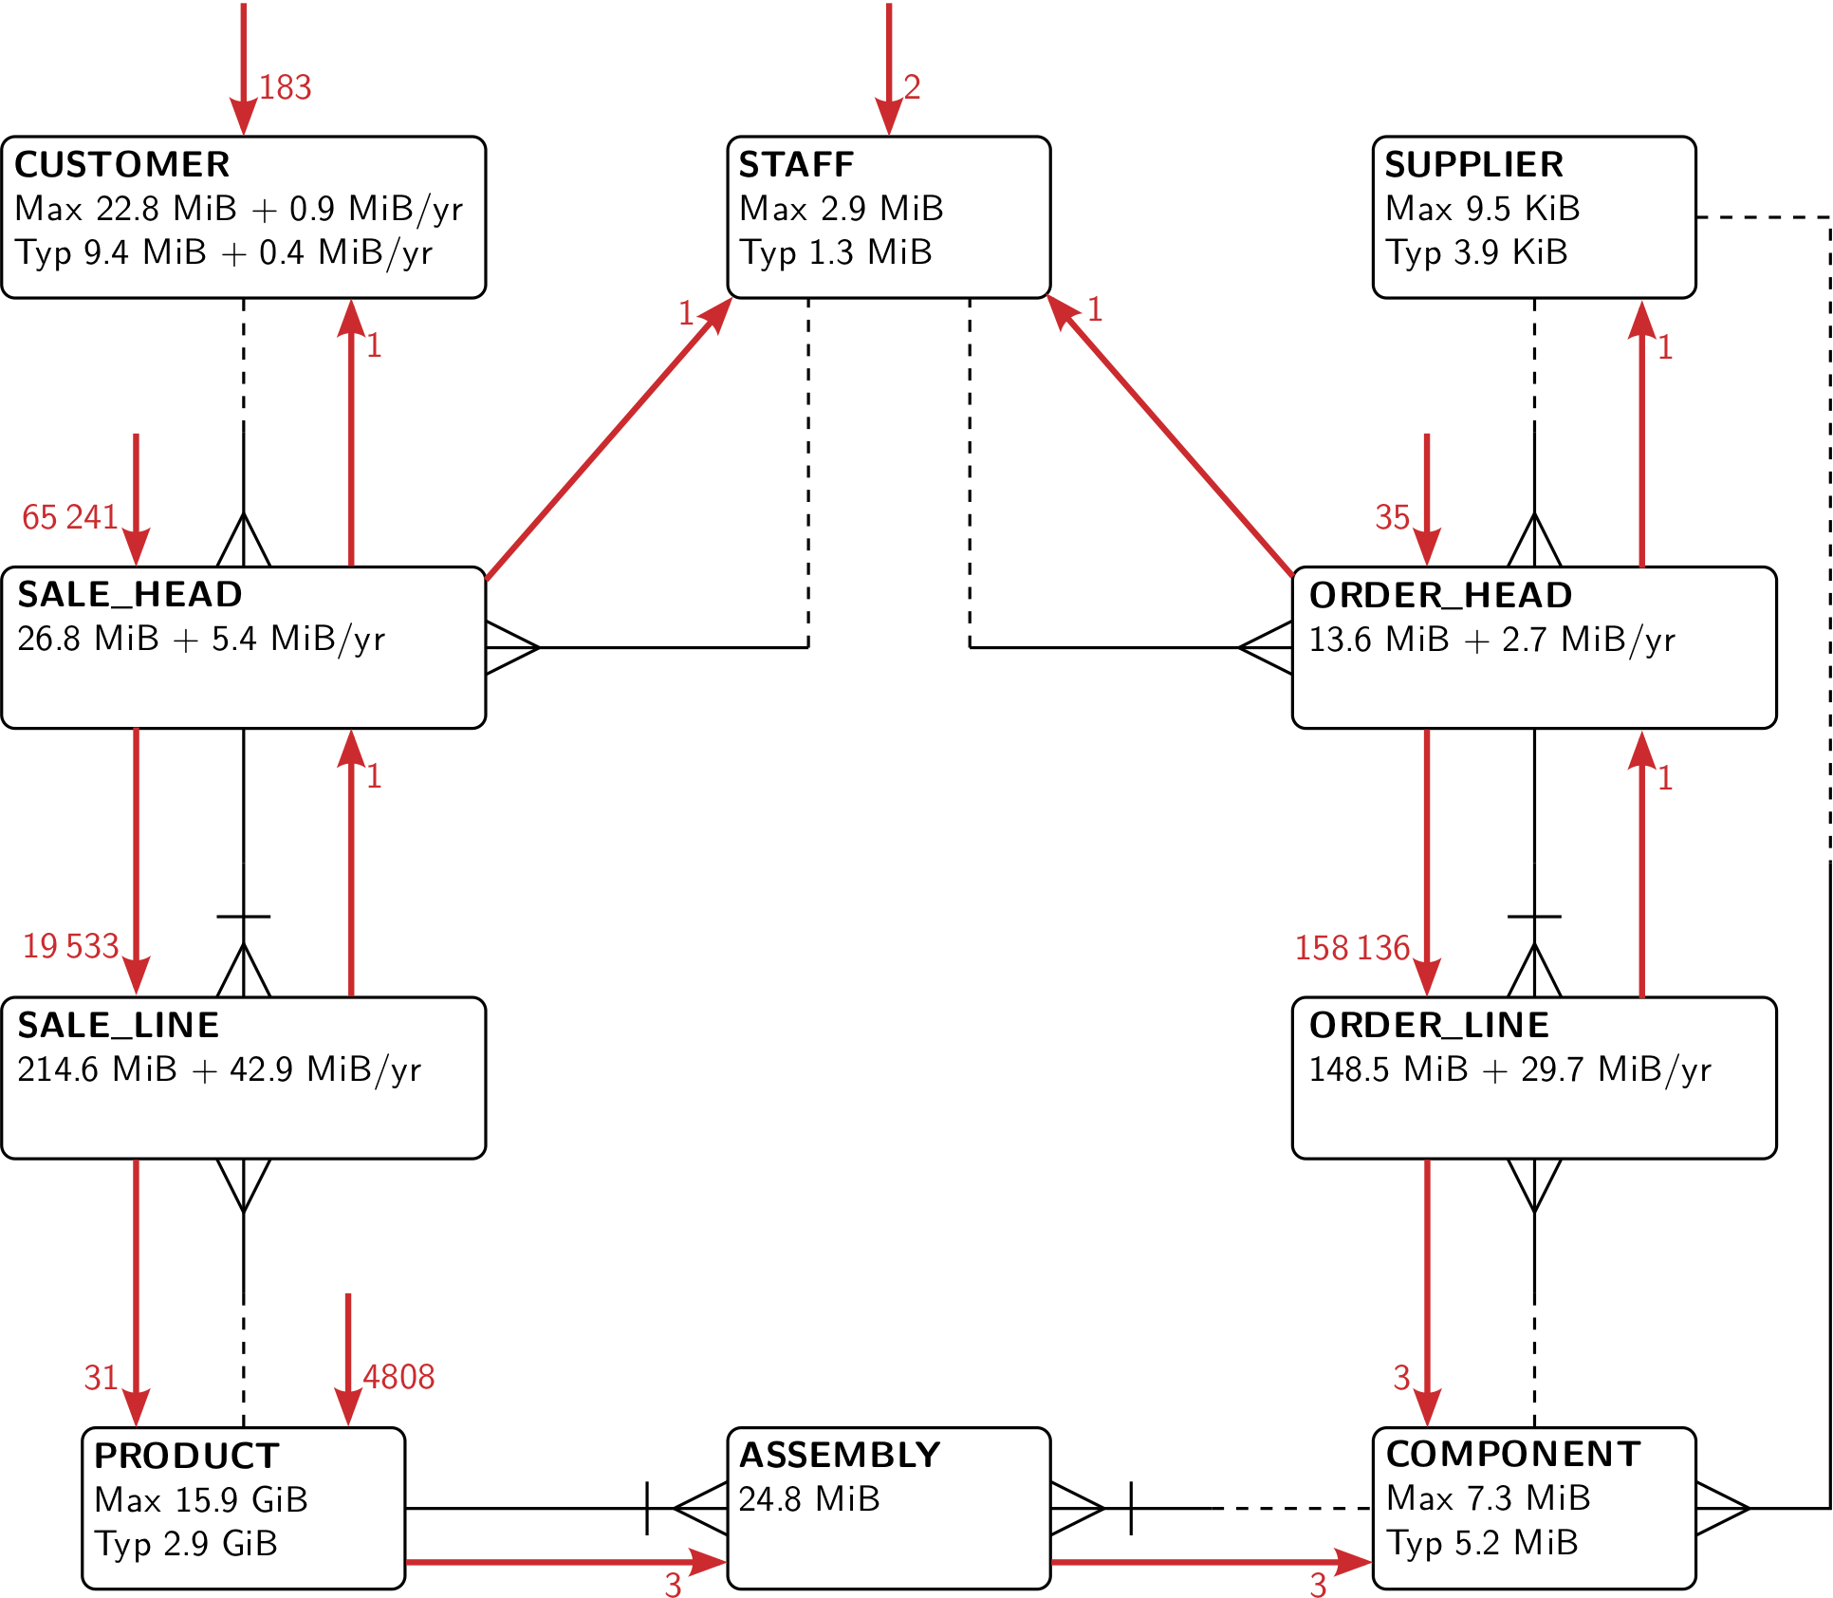
Figure 1. Composite usage map of Better Digital’s database

2.3 Identified problem areas within the database
The following have been identified as the most significant problem areas within the BDL database. They are divided into three groups, in descending order of significance.
You are required to provide a tuning solution for the two following critical problem areas:
Problem Area 1 The transaction that updates a customer’s activity level is a significant problem. It is causing extremely frequent full table scans on the Sale_head table, which is significantly slowing the entire system.
Problem Area 2 Inventory staff are complaining about the performance of retrieving new sales.
You are required to provide a tuning solution for at least one of the following serious problem areas:
Problem Area 3 Sales & Marketing staff are having problems looking up product details for customers.
Problem Area 4 Performance is poor for entering new sales into the database.
Problem Area 5 Performance is poor for entering new orders into the database.
Problem Area 6 Inventory staff are having problems updating the database when shipments of components arrive.
Problem Area 7 Finalising the monthly accounts tends to overload the system.
You are required to provide a tuning solution for at least two of the following minor problem areas:
Problem Area 8 Changing the status of sales and orders.
Problem Area 9 Downloading assembly details.
Problem Area 10 Generating the two mail merges.
Problem Area 11 Generating the monthly product catalogue.
Problem Area 12 Generating monthly salaries.
Problem Area 13 Adding new customers.

